DESIGN AND ANALYSIS OF ALGORITHMS

**NAME : P.R.DHANVIN**

**DEPT & SEC : CSE & ‘B’**

**ROLL NO : 230701071**

**WEEK : FINDING TIME COMPLEXITY OF ALGORITHMS**

Problem 1: Finding Complexity using Counter Method

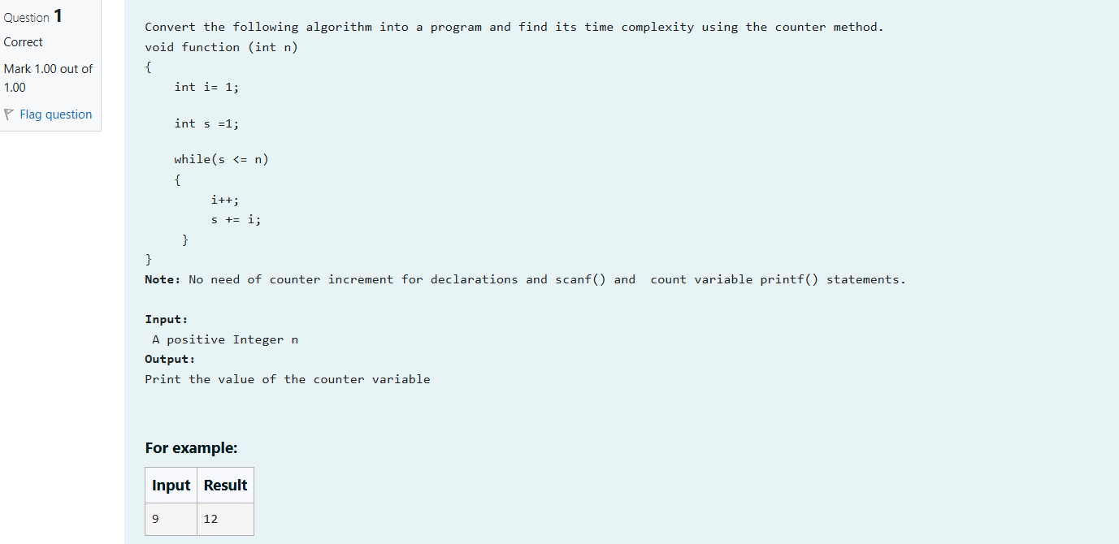

**#include<stdio.h>**

**int main()**

**{**

**int n;**

**scanf("%d",&n);**

**int a=0;**

**int i=1;a++;**

**int s=1;a++;**

**while(s<=n){**

**a++;**

**i++,a++;**

**s+=i,a++;**

**}a++;**

**printf("%d",a);**

**}**

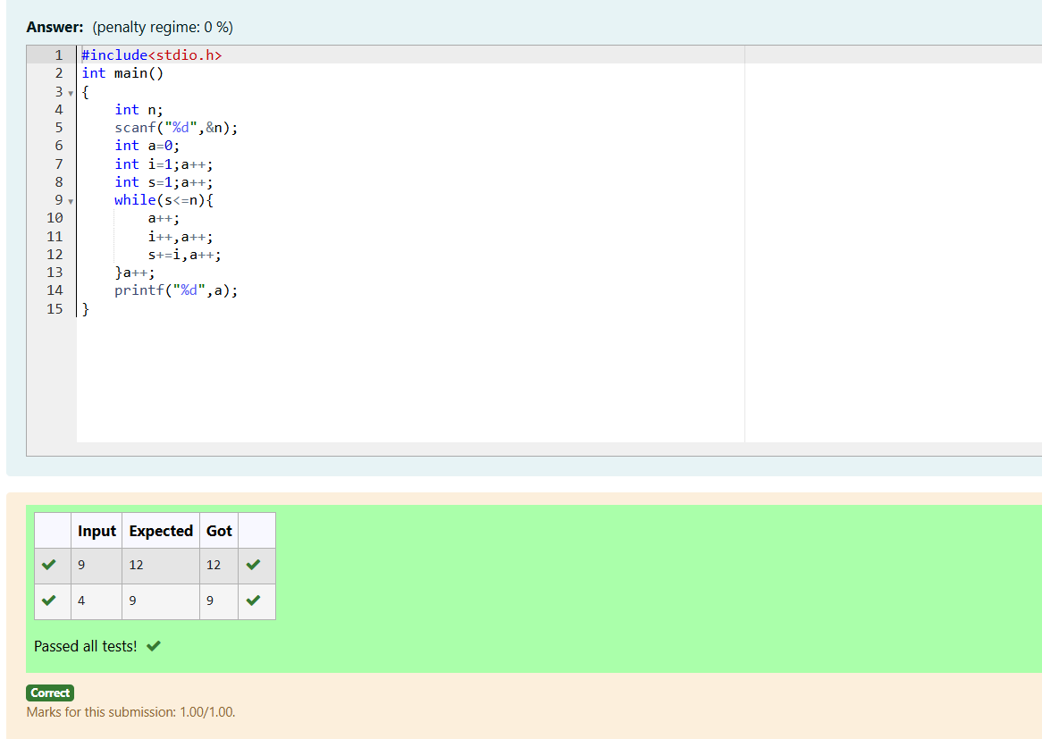

Problem 2: Finding Complexity using Counter method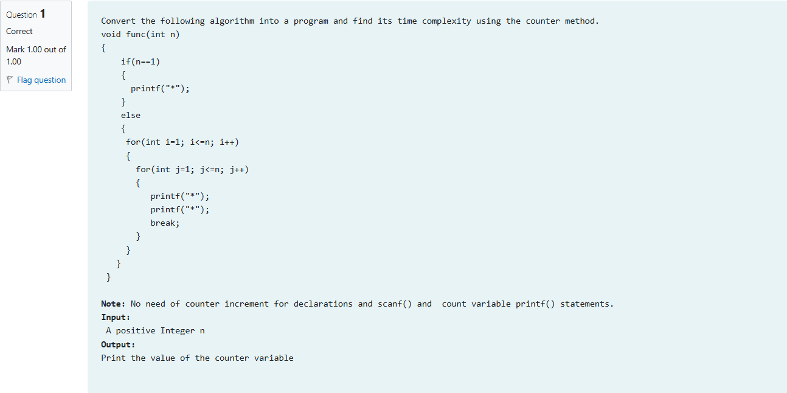ter method

**#include<stdio.h>**

**int main(){**

**int n,a=0;**

**scanf("%d",&n);**

**if(n==1){**

**a++;**

**//printf("*");**

**}**

**else{**

**a++;**

**for(int i=1;i<=n; i++,a++){**

**a++;**

**a++;**

**for(int j=1; j<=n; j++,a++){**

**a++;**

**//printf("*");**

**//printf("*");**

**break;**

**a++;**

**}**

**a++;**

**}**

**a++;**

**}**

**printf("%d",a);**

**}**

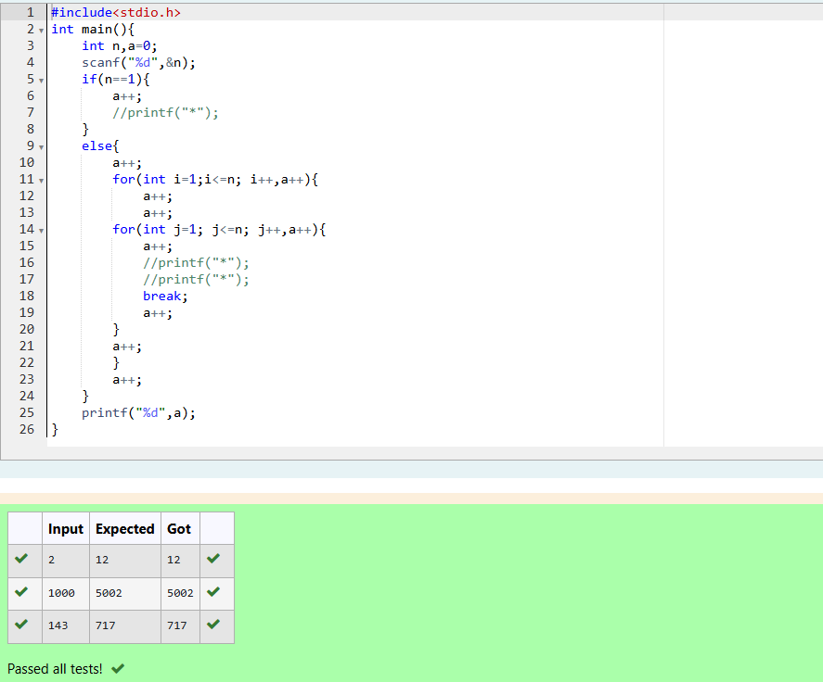

Problem 3: Finding Complexity using Counter Method

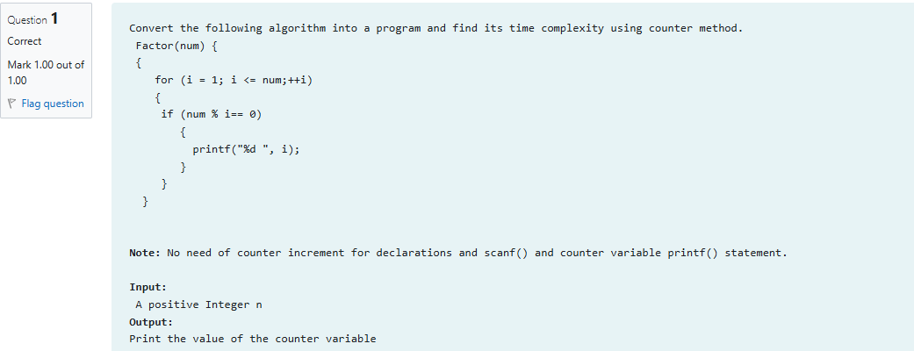

**#include<stdio.h>**

**int main(){**

**int n,a=0;**

**scanf("%d",&n);**

**for(int i=1;i<=n;++i,a++){**

**a++;**

**if(n%i==0){**

**a++;**

**//printf("%d ",i);**

**}**

**}**

**a++;**

**printf("%d ",a);**

**}**

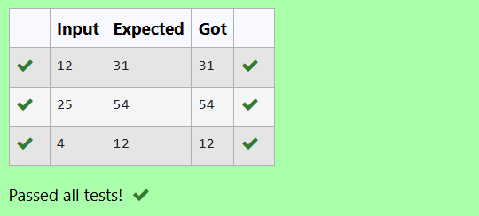

Problem 4: Finding Complexity using Counter Method

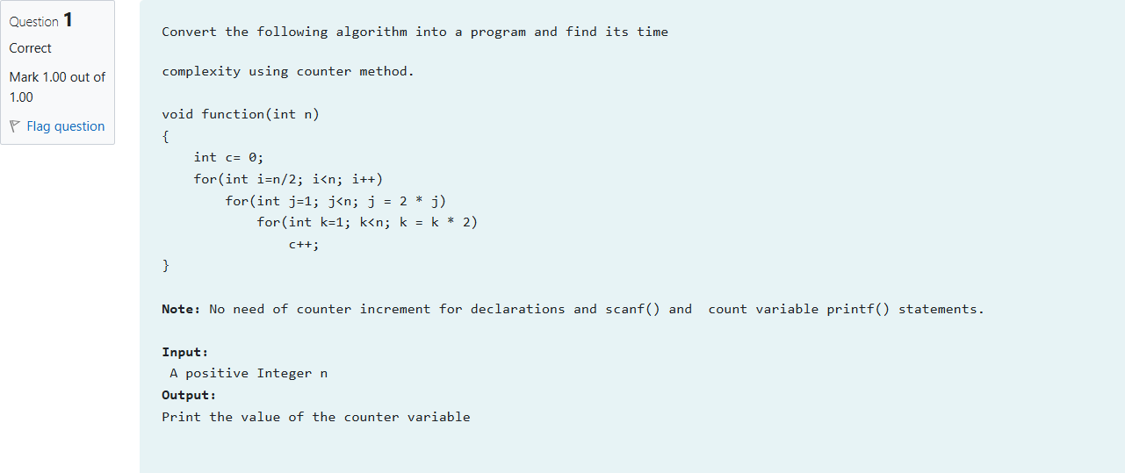

**#include<stdio.h>**

**int main(){**

**int n,a=0;**

**scanf("%d",&n);**

**int c=0;**

**a++;**

**for(int i=n/2;i<n;i++){**

**a++;**

**for(int j=1;j<n; j=2*j){**

**a++;**

**for(int k=1;k<n; k=k*2){**

**a++;**

**c++;**

**a++;**

**}a++;**

**}a++;**

**}a++;**

**printf("%d",a);**

**}**

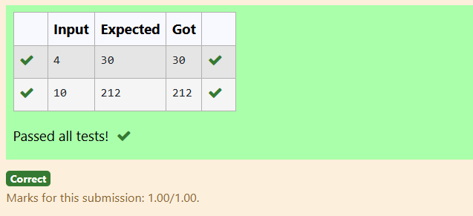

Problem 5: Finding Complexity using counter method

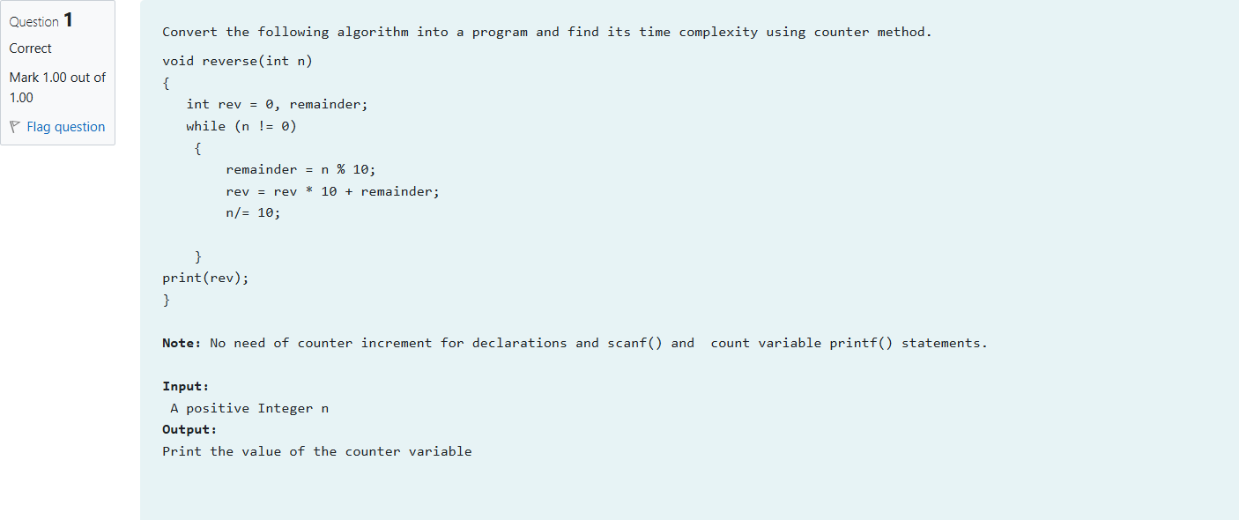 **#include<stdio.h>**

**int main(){**

**int n,a=0;**

**scanf("%d",&n);**

**int rev =0,remainder;**

**a++;**

**while(n!=0){**

**a++;**

**remainder=n%10;**

**a++;**

**rev=rev*10+remainder;**

**a++;**

**n/=10;**

**a++;**

**}**

**a++;**

**a++;**

**printf("%d",a);**

**}**

